

NEXT METERS GLOBAL :
Paapri Cloud Technology
MARKETING TO ROI

Creating Campaign Email Address :
Step 1: Login to NetSuite with Marketing Manager role. Navigate: Setup->Marketing -> Email Addresses-> New.
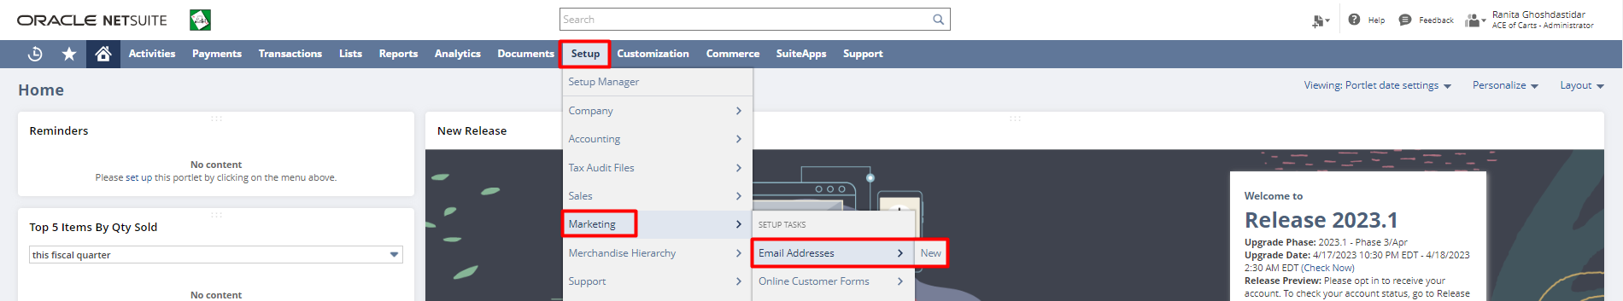
Step 2: Enter an email address via which you want to send email campaigns. Click the “Save” button. Once you hit save an email with a verification code is sent on the provided email.
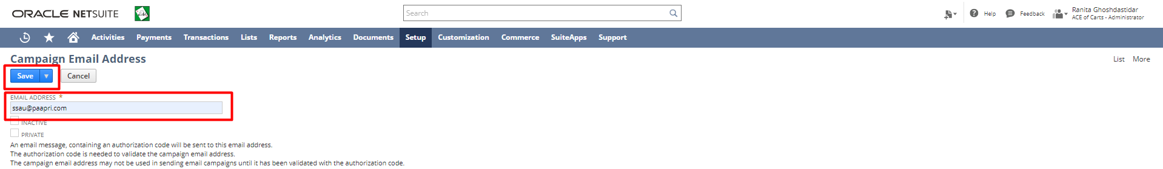
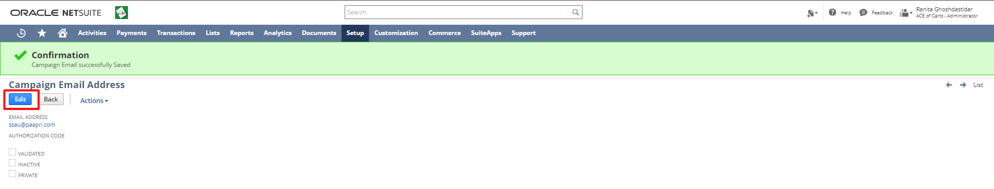
Step 3: Click the “Edit” button. Enter the authorization code received on your email. Click the “Save” button. This validates the campaign email address.
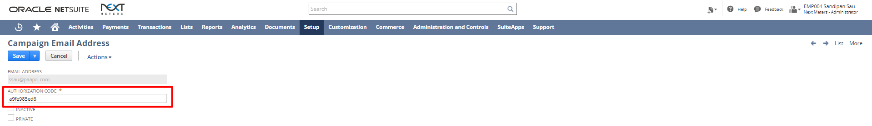

Setting up the Marketing Preferences:
Step 1: Login to NetSuite with Marketing Manager role. To setup Marketing Preferences, navigate:
Setup-> Marketing-> Marketing Preferences.
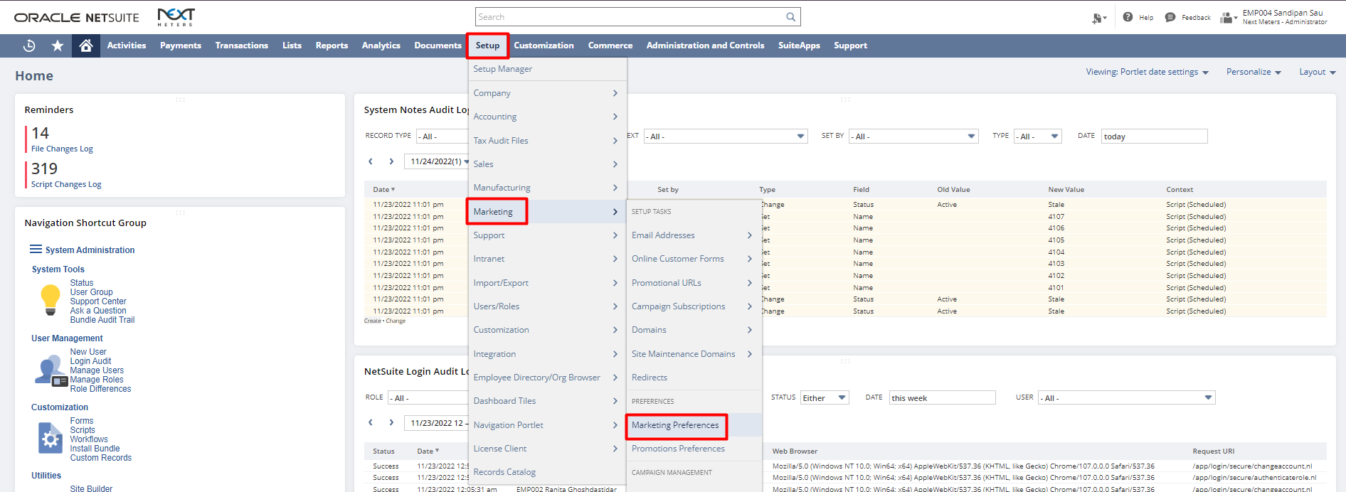

Step 2: Select a type for the Marketing Template.

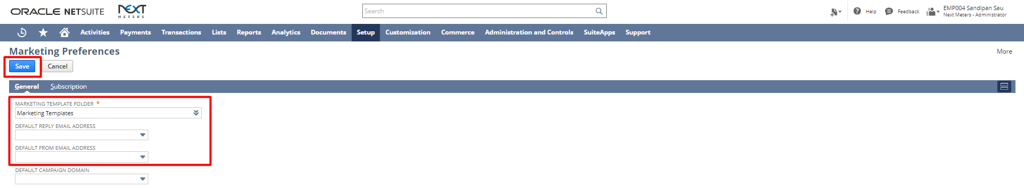
Creating Marketing Templates:

Step 1: Login to NetSuite with Marketing Manager role. Then navigate: Documents-> Templates-> Marketing Templates-> New.
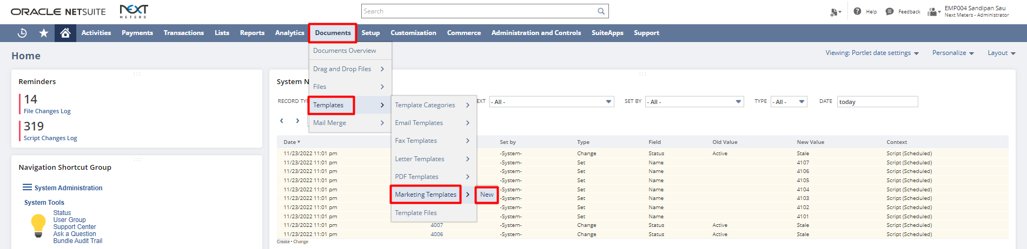
Step 2: Select a type for the Marketing Template.
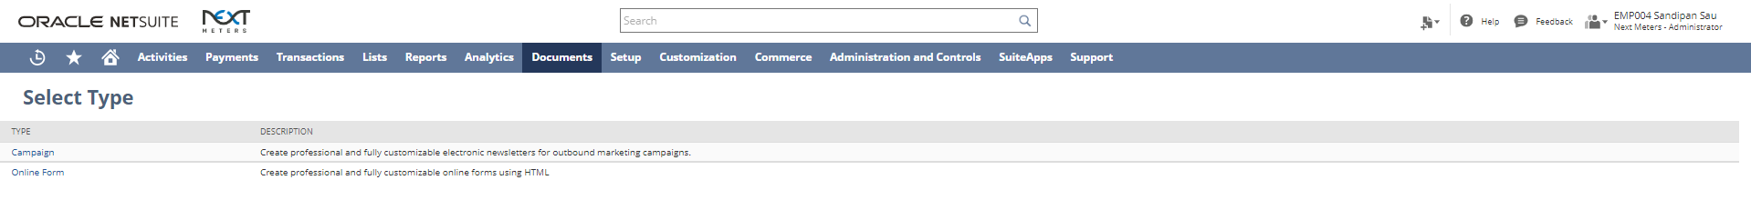
Step 3: Select the Template Layout.
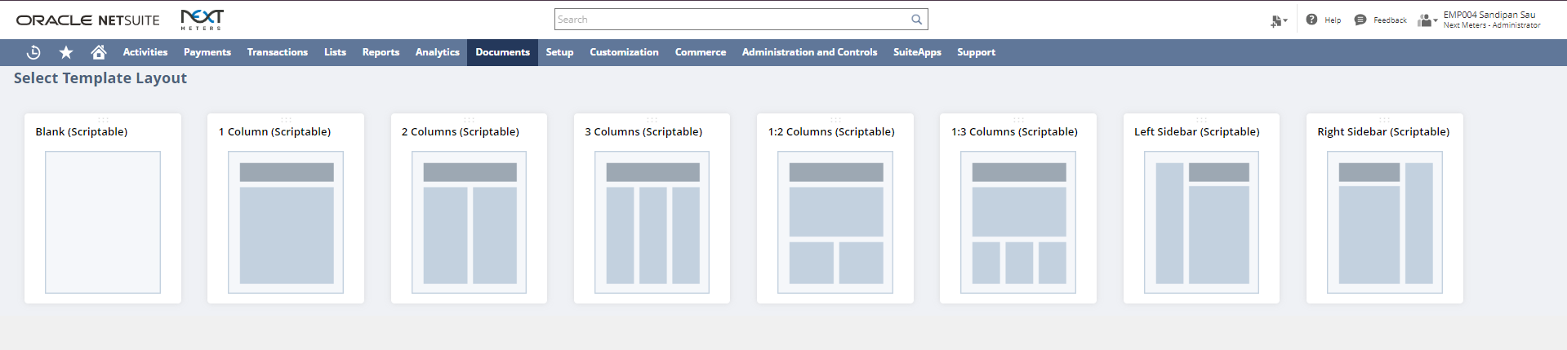

Creating Promotions:

Step 1: Login to NetSuite with Marketing Manager role. Then navigate: Lists-> Marketing-> Promotions-> New.
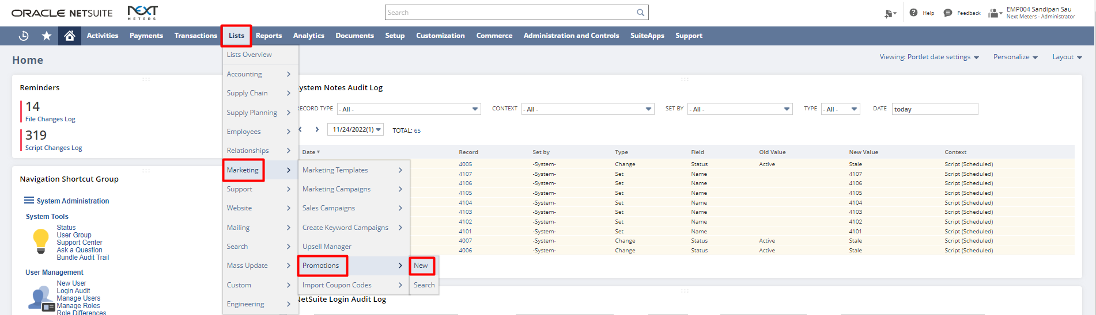
Step 2: Select a type for the Promotion.
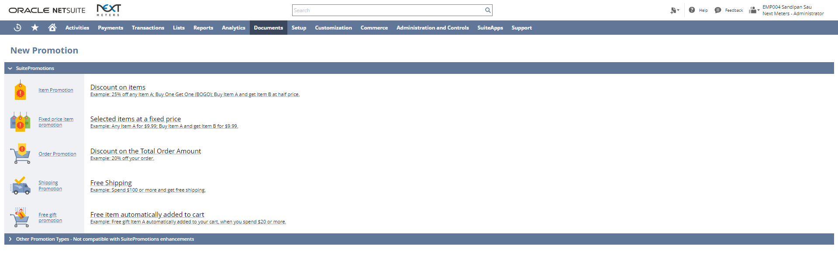
Step 3: Enter a name for the promotion. Select a start and end date for the promotion if any. Under Further Settings select Combinable Promotion if this combination will be combined with another promotion. Select Exclusive Promotion for an exclusive promotion. Check the checkbox “This Promotion can be applied automatically” to automatically apply the promotion. Select a Discount Item for Accounting Purpose of this promotion. Select an option for “What the Customer needs to buy”.
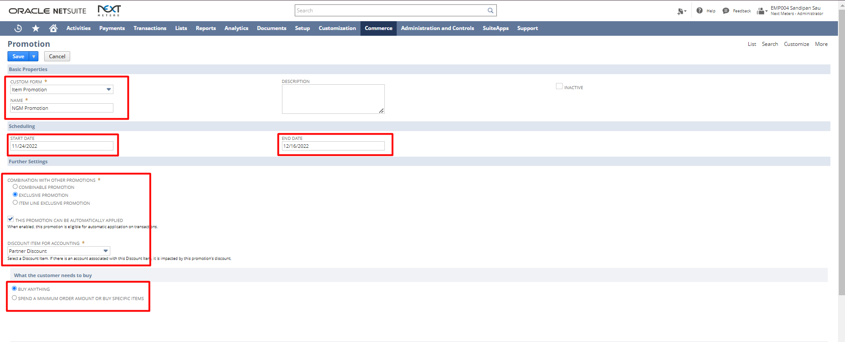
Step 4: Enter a Discount rate. Select the % or Flat radio button for how the discount will be applied. Select Items for which the discount will be applicable from the Item dropdown. Select an option for “Apply Discount to”. Select the coupon code type and enter a coupon code for the promotion.

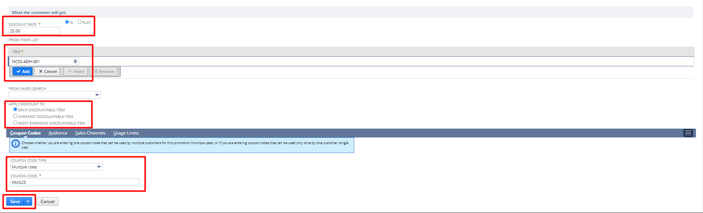

Step 5: Click on the Audience subtab. Select the Audience for this promotion. You may select the locations in which the promotion is applicable by clicking on the Sales Channel subtab. Click on Specific Locations subtab and select the locations for this promotion. Click on the “Save” button.
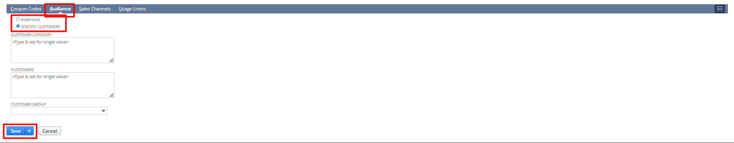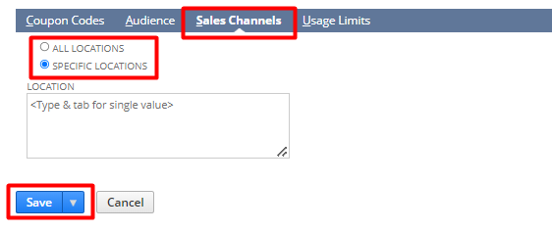

Applying Promotions to a Sales Order:

Step 1: Login to NetSuite with Administrator role. Then navigate: Transactions->Sales->Enter Sales Orders.
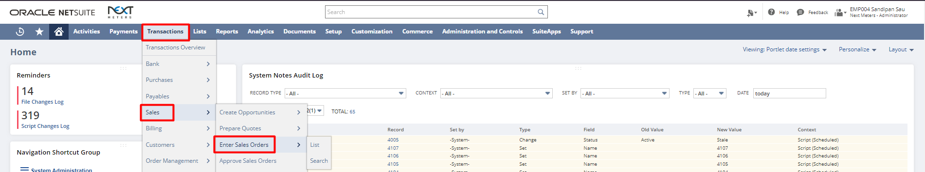
Step 2: Select a Customer from the Customer dropdown. Under the Promotion subtab select promotion from the dropdown. Click the “Save” button.
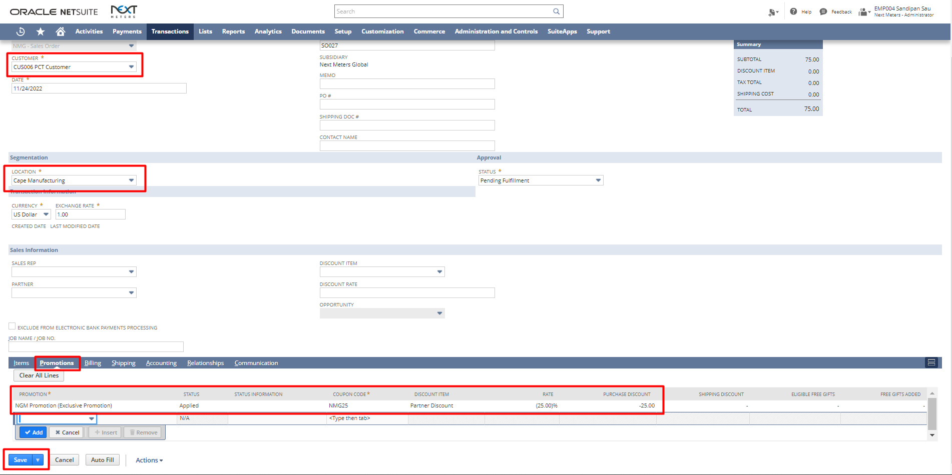
This creates a Sales Order with promotion in NetSuite.

Creating Customer Groups:

Step 1: Login to NetSuite with Marketing Manager role. Then navigate: Lists-> Relationships-> Groups-> New.
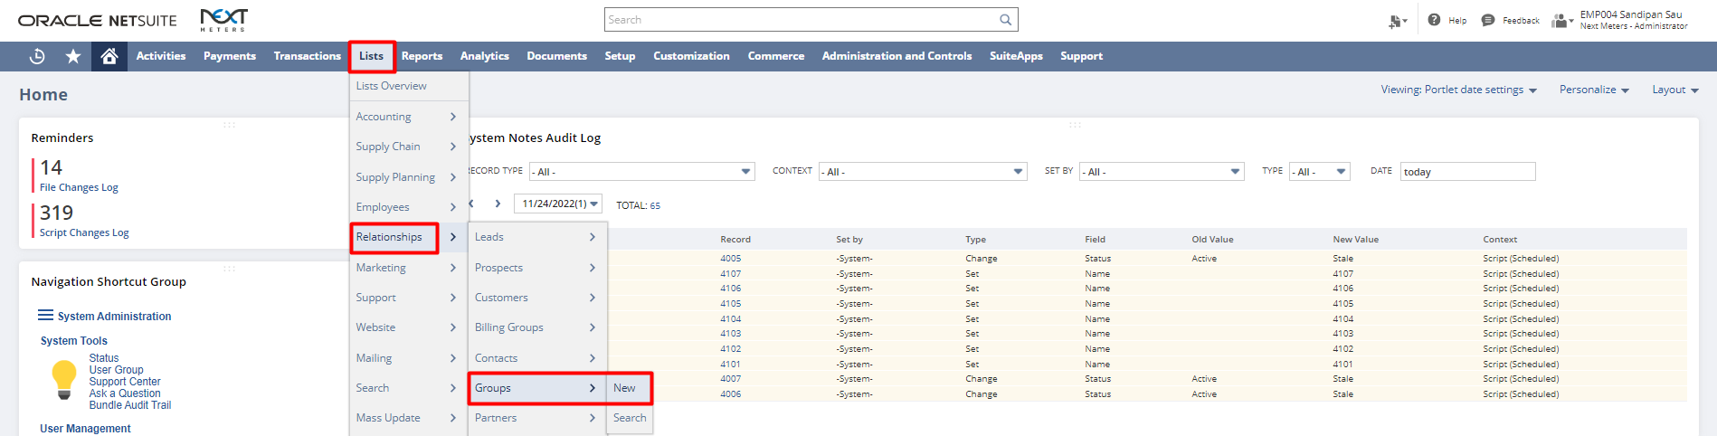
Step 2: Select the type for the group whether Static or Dynamic. From the dropdown of “What kind of members you would like to include?” select Customer. Click the “Continue” button.
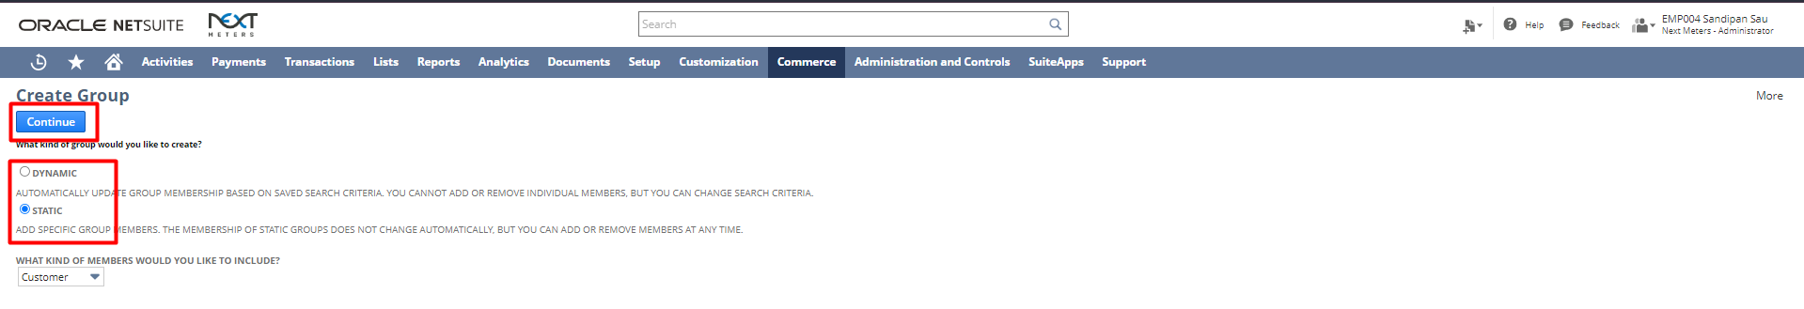
Step 3: Enter a name for the Group. Under the Members subtab from the name dropdown select the customer for this group. Click “Add” button to add them to the group. Click the “Save” button.
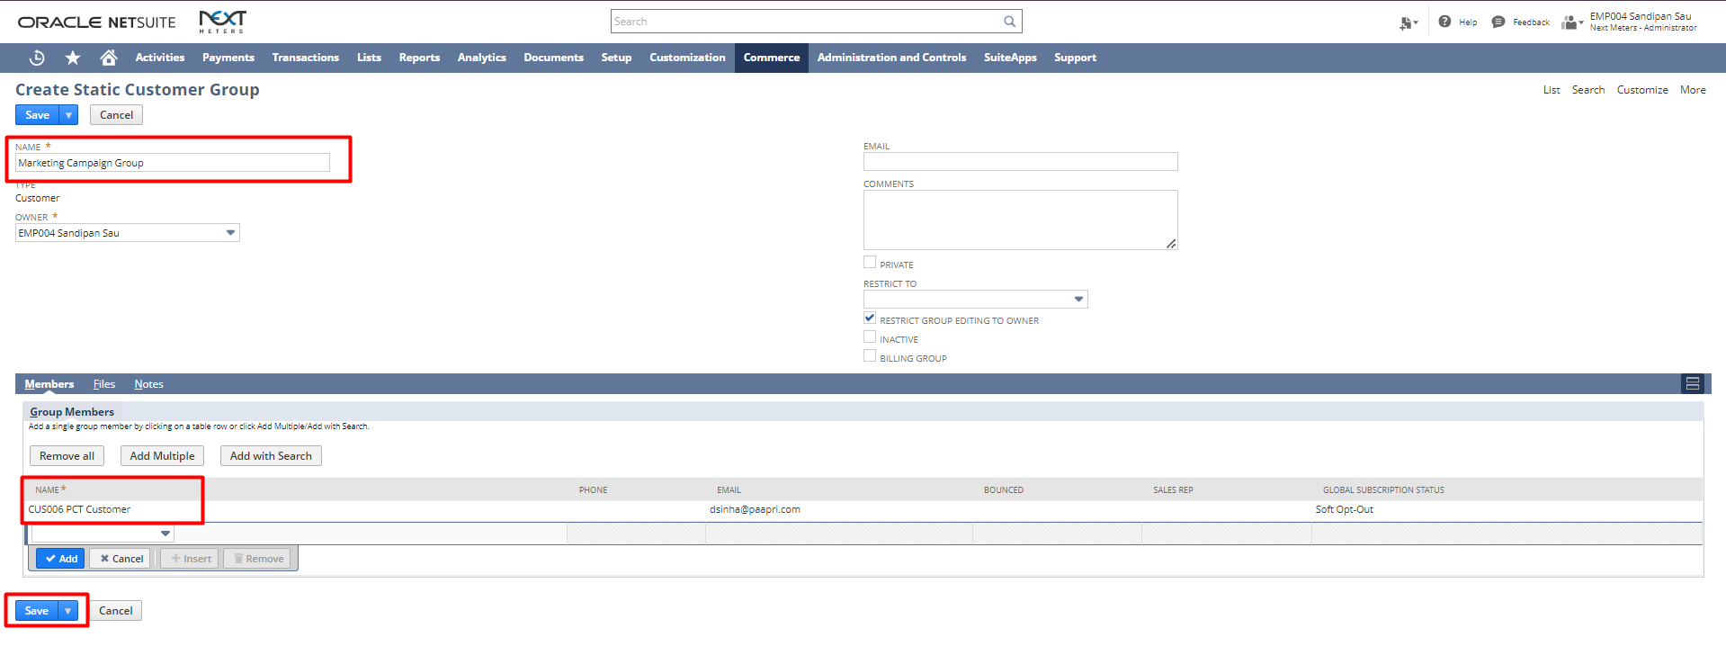

Creating Marketing Campaigns:
Step 1: Login to NetSuite with Marketing Manager role. Then navigate: Lists-> Marketing-> Marketing Campaigns-> New.
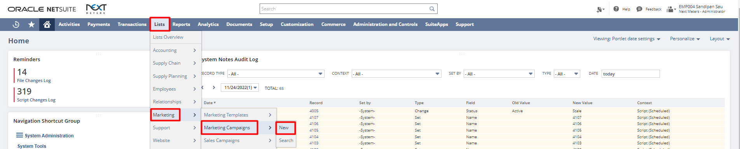
Step 2: Enter the title for the Marketing Campaign. Enter the start and end date. Select the Promotion code from the dropdown. Select the Items for the Marketing Campaign. Under the Events subtab select the Group from the Target Group dropdown. Then select the Template, enter a Title, select a Subscription and select a Channel. Select the status as Execute and enter the time at which you want this email campaign to be send.

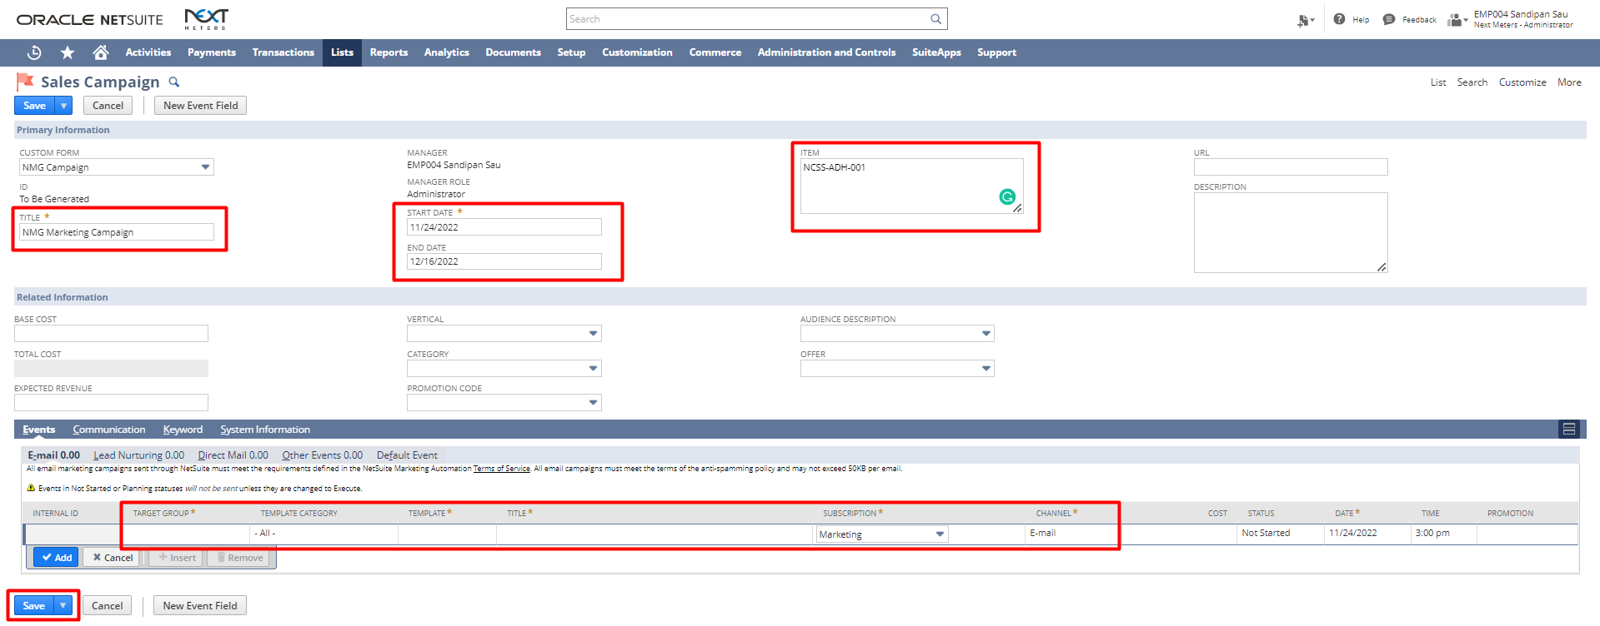
This creates a campaign in NetSuite.

Signature: _____________________________ Date: ______________________

Disclaimer:
Upon signing off on the process flow document, you are confirming that the process has been set up per the SOW within NetSuite per your business's needs. Any changes or modifications requested after sign-off will need to be a "change request" at an additional fee.

*** PLEASE ensure that you have logged into NetSuite and tested the process prior to signing off on the setup. Paapri requires sign-off on this document prior to moving forward with any additional design meetings.

